**The Silent Epidemic: Occupational Health Challenges in the Information Technology Sector**

Researcher **– MOHIT SINGH**

Branch Student**- Artificial Intelligence and Data Science**

College **– Maharaja Agrasen Institute of Technology Rohini Sector 22**

Date **– 29/4/25**

**Abstract**

This report delivers a comprehensive analysis of occupational health challenges prevalent among IT professionals aged 20 to 60, whose sedentary desk jobs and prolonged computer use precipitate a range of physical and mental health issues. Examining scientific literature and statistical data, the study reveals the causes, effects, symptoms, and prevalence of musculoskeletal disorders, vision problems (Computer Vision Syndrome), psychological distress, burnout, metabolic dysfunctions, and hormonal imbalances. With a focus on global trends and specific attention to India's burgeoning IT sector, the research underscores the necessity for early detection and evidence-based interventions. The findings emphasize the importance of ergonomic solutions, physical activity promotion, mental health support programs, and innovative workplace design to foster a healthier, more productive IT workforce.

**Introduction**

The information technology (IT) sector has become a cornerstone of the modern global economy, with its continuous expansion and increasing integration into nearly every facet of life. This growth has led to a significant surge in employment, offering numerous opportunities for individuals with specialized skills. However, this progress has also brought forth a less visible challenge: the adverse health effects associated with the nature of work within the IT industry, particularly for professionals engaged in sedentary desk jobs involving prolonged computer use. While the sleek offices and innovative technologies often associated with the IT sector might suggest a progressive and comfortable work environment, the reality for many employees involves long hours spent in front of computer screens, frequently leading to a variety of physical and mental health problems that can accumulate over their careers.

This report aims to provide a comprehensive analysis of the occupational health challenges faced by IT professionals aged 20 to 60 who are engaged in these sedentary work patterns. By examining the existing body of scientific literature and statistical data, this analysis will delve into the causes, effects, symptoms, and prevalence of a wide range of health issues, including physical ailments, mental health challenges, metabolic disorders, and hormonal imbalances. While the scope of this report encompasses global trends, it will also pay particular attention to the situation in India, where the IT sector has experienced remarkable growth. Furthermore, this report will explore evidence-based solutions, interventions, and preventative measures that can be implemented to address these health problems at an early stage, with a focus on practical and effective strategies that can be readily adopted within the typical office environment. Understanding the multifaceted nature of these occupational health challenges is crucial for fostering a healthier and more productive workforce within the IT sector, ultimately benefiting both employees and organizations alike.

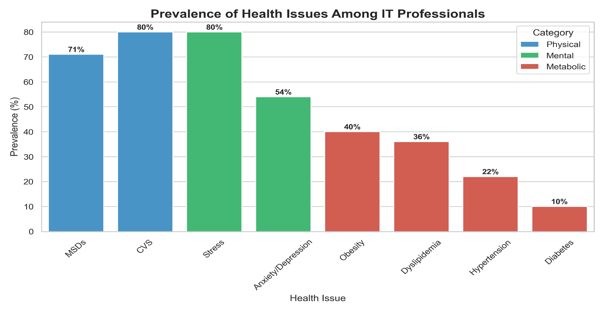

**Detailed Analysis of Physical Health Problems**

The prolonged and often static nature of desk work in the IT sector, coupled with intensive computer use, contributes to a range of physical health problems that can significantly impact the well-being and productivity of professionals in this field. These issues primarily manifest as musculoskeletal disorders and vision problems, arising from specific ergonomic and environmental factors inherent in their daily work routines.

**Musculoskeletal Disorders (MSDs)**

Musculoskeletal disorders represent a significant category of physical health problems affecting IT professionals. These disorders encompass a variety of conditions that impact the muscles, bones, nerves, tendons, and ligaments, often resulting in pain, discomfort, and limited mobility.

**Posture-Related Issues: Back Pain, Neck Pain, and Shoulder Pain**

Prolonged periods of sitting, a hallmark of many IT roles, place considerable stress on the musculoskeletal system, particularly when combined with poor posture and inadequately adjusted workstations. While sitting requires less muscular effort than standing, maintaining a steady position for extended durations can still lead to physical fatigue and reduce blood circulation to the muscles, bones, tendons, and ligaments, resulting in stiffness and pain. Back pain is one of the most commonly reported issues among computer users, often stemming from years of faulty posture, which can also affect the position and function of vital organs. Similarly, neck pain is highly prevalent, with studies indicating a positive correlation between neck pain and computer processing posture, especially when the neck is frequently held in a forward bent position for prolonged periods. Shoulder pain also arises from poor workstation design and prolonged static postures, contributing to overall discomfort and potential long-term health issues if not addressed. The combination of these posture-related issues creates a significant biomechanical burden on IT professionals, underscoring the need for ergonomic interventions.

**Upper Extremity Disorders: Carpal Tunnel Syndrome, Cubital Tunnel Syndrome, and Tendinitis**

Beyond posture-related pain, the repetitive nature of tasks such as typing and using a mouse can lead to the development of upper extremity disorders. Repetitive strain injuries (RSIs) like carpal tunnel syndrome (CTS) occur due to the compression of the median nerve in the wrist, often resulting in numbness, tingling, and pain in the hand and fingers. Prolonged or awkward wrist positions during computer use can increase the risk of CTS. Another nerve compression disorder, cubital tunnel syndrome, affects the ulnar nerve as it passes through the elbow. Activities involving prolonged bending of the elbow, such as typing or using a phone, can inflame this nerve, leading to numbness and tingling in the ring and pinky fingers, as well as elbow pain. Tendinitis, the inflammation of a tendon, is also common among IT professionals due to the overuse and repetitive motions of the hands, wrists, and arms during computer work. These upper extremity disorders can significantly impact the dexterity and functionality of the hands and arms, affecting the ability of IT professionals to perform their daily tasks.

**Causes, Biomechanics, and Pathophysiology**

Musculoskeletal disorders in IT professionals are typically the result of a complex interplay of several factors. Ergonomic risk factors such as awkward postures, including prolonged or repetitive reaching, bending, and twisting, combined with repetitive motions, forceful exertions, and static or sustained postures, contribute significantly to the development of MSDs. These biomechanical stressors, arising from prolonged sitting and improper body mechanics at the workstation, lead to muscle fatigue, inflammation of tendons and ligaments, and compression of nerves. For instance, maintaining a flexed or extended hand position while using a keyboard or mouse can increase the risk of carpal tunnel syndrome. The lack of sufficient rest breaks further exacerbates these issues, preventing the body from recovering from the sustained physical demands of computer work.

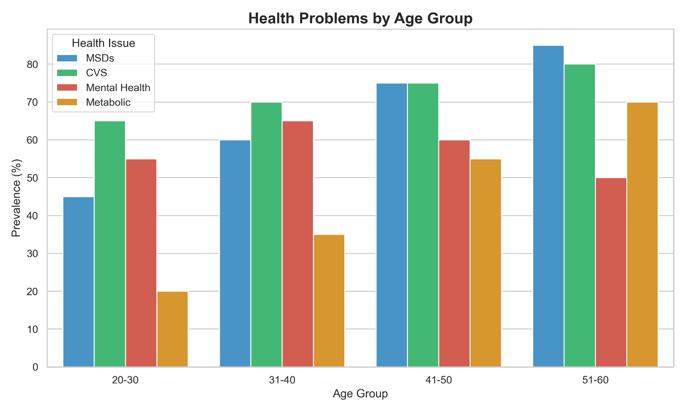

**Symptoms and Effects on Daily Functioning**

The symptoms of musculoskeletal disorders experienced by IT professionals are varied and can range from mild discomfort to severe pain. Common symptoms include localized pain in the back, neck, shoulders, hands, wrists, or arms, as well as numbness, tingling sensations, stiffness, and a limited range of motion in the affected joints. These symptoms can have a profound effect on an individual's ability to perform daily activities, both work-related and personal. Tasks such as typing, using a mouse, lifting objects, or even sleeping can become difficult and painful. The persistent pain and discomfort associated with MSDs can also lead to reduced work productivity, increased absenteeism, and a significant decline in the overall quality of life for IT professionals.

**Prevalence and Incidence Rates in IT Professionals**

The prevalence of musculoskeletal disorders among IT professionals is alarmingly high across the globe. Studies have reported a wide range of prevalence rates, from a minimum of 20% to a maximum of 89%, indicating that a substantial portion of the workforce in this sector is affected by these conditions. Specific MSDs such as back pain are particularly common, with one study in a general working population reporting a prevalence of 19.4%, while rates are likely higher among IT professionals who spend prolonged hours sitting. Neck pain is another frequent complaint, with studies showing that it affects a significant percentage of computer workers. Carpal tunnel syndrome, a well-known RSI, has been found to affect around 13.1% of computer professionals in India in one study. Research conducted in Nagpur, India, revealed that body ache, encompassing backache and headache, was reported by 59% of computer workers, highlighting the widespread nature of musculoskeletal discomfort in this demographic. A comprehensive literature review focused on India indicated that the prevalence of work-related musculoskeletal disorders among IT professionals ranges from 58% to 71%. These statistics underscore the significant burden of MSDs within the IT sector and emphasize the critical need for effective prevention and management strategies.

**Vision Problems (Computer Vision Syndrome - CVS)**

Computer Vision Syndrome, also known as digital eye strain, is another prevalent physical health issue among IT professionals. It encompasses a group of eye and vision-related problems that result from prolonged usage of computers and other digital devices.

**Eye Strain, Dry Eyes, Blurred Vision, and Headaches**

The sustained visual demands of working with computers for extended periods place a significant strain on the eyes, leading to a variety of uncomfortable symptoms. Eye strain is a common complaint, often described as a feeling of tiredness or soreness in the eyes. Dry eyes, characterized by a gritty or burning sensation, are also frequently reported by computer users, primarily due to a reduced blinking rate during screen time. Blurred vision, either temporary or persistent, is another common symptom of CVS, making it difficult to focus on both the screen and distant objects. Headaches, often occurring behind the eyes or in the temples, are also frequently associated with prolonged computer use, potentially due to increased muscle tension or eye strain. These symptoms collectively contribute to the discomfort and reduced efficiency experienced by many IT professionals.

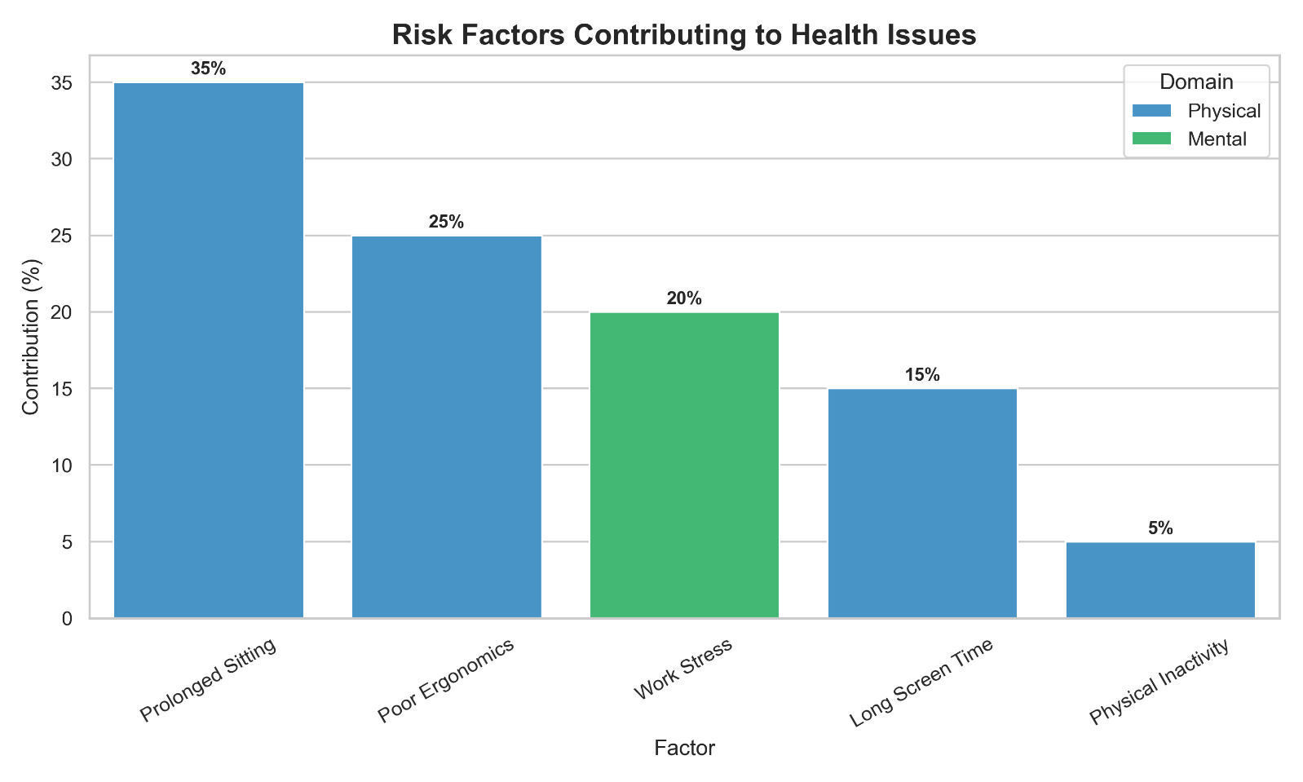

**Causes Related to Prolonged Screen Time and Work Environment**

Several factors related to prolonged screen time and the typical work environment of IT professionals contribute to the development of Computer Vision Syndrome. Sustained focus on a computer screen at a fixed distance for long durations requires the eye muscles to work continuously, leading to fatigue. Glare from the computer screen, as well as from surrounding light sources, can also strain the eyes and make it difficult to see clearly. Improper lighting conditions in the workspace, such as too bright or too dim lighting, can further exacerbate eye strain. Additionally, viewing devices at improper distances, either too close or too far away, forces the eyes to work harder to maintain focus. Pre-existing or uncorrected vision problems can also significantly worsen the symptoms of CVS, making it even more challenging for IT professionals to work comfortably at their computers.

**Symptoms and Long-Term Effects on Vision Health**

While the immediate symptoms of Computer Vision Syndrome, such as eye strain, dry eyes, and headaches, are bothersome, prolonged and untreated CVS can also lead to more persistent and potentially long-term vision problems. Difficulty in refocusing the eyes, particularly when switching between the computer screen and other distances, can become more pronounced over time. Some individuals may experience double vision, making it challenging to perform tasks requiring visual accuracy. Although there is no conclusive evidence that eye fatigue from computer use permanently damages eyesight, the chronic strain and discomfort can significantly impact an individual's quality of life and their ability to perform their work effectively. Therefore, addressing the early symptoms of CVS is crucial to prevent potential long-term vision health issues.

**Prevalence and Impact on Productivity**

Computer Vision Syndrome is a highly prevalent condition among computer users worldwide. Studies have indicated that anywhere from 50% to 90% of individuals who work extensively with computers experience symptoms of CVS. Research conducted specifically in India has also revealed high prevalence rates among IT professionals and related populations. For instance, studies have reported CVS prevalence ranging from 70% to 80% among computer professionals and students in India. The discomfort and symptoms associated with CVS can significantly impact work productivity. Headaches, eye strain, and blurred vision can make it difficult for IT professionals to concentrate and perform their tasks efficiently, potentially leading to errors and reduced output. The widespread prevalence of CVS in the IT sector underscores the importance of implementing effective preventative and management strategies to safeguard the visual health and maintain the productivity of this critical workforce.

**Detailed Analysis of Mental Health Challenges**

The demanding and often high-pressure nature of work in the IT sector contributes to a significant burden of mental health challenges among professionals in this field. These challenges encompass a range of issues, including psychological distress, burnout syndrome, cognitive impairment, social isolation, and various workplace stressors.

**Psychological Distress**

Psychological distress, encompassing conditions such as stress, anxiety, and depression, is highly prevalent among IT professionals. The demanding work environments, characterized by long hours, tight deadlines, and the constant pressure to acquire new skills in a rapidly evolving technological landscape, are significant contributing factors. Studies conducted in India have consistently shown a substantial percentage of IT professionals experiencing these issues, with some surveys reporting stress levels as high as 80%. Factors such as job insecurity in a dynamic industry, poor work-life balance due to long hours and the expectation of constant availability, and a lack of recognition for their efforts also contribute significantly to the mental health challenges faced by IT professionals. The competitive nature of the industry and the pressure to remain at the forefront of technological advancements further exacerbate these stressors, creating a significant impact on the overall well-being of IT professionals, particularly in India.

**Burnout Syndrome**

Burnout syndrome is another critical mental health concern within the IT sector. Characterized by emotional exhaustion, an increased mental distance from one's job often manifested as negative or cynical feelings, and a sense of reduced professional efficacy, burnout is a common experience for many tech professionals. Long working hours, often seen as a representation of dedication in the tech culture, and a pervasive culture of overwork contribute significantly to the development of burnout. Studies have indicated that a substantial proportion of tech workers, nearly 2 in 5 in some surveys, show a high risk of burnout, with a significant number of these individuals actively considering leaving their roles in the near future. This widespread prevalence of burnout has significant implications for both the individual well-being of IT professionals and the overall productivity and sustainability of organizations within the sector.

**Cognitive Impairment**

The high cognitive demands of IT work, combined with the pervasive effects of stress and burnout, can also lead to various forms of cognitive impairment among professionals in this field. Difficulties in concentrating on complex tasks, memory problems affecting both short-term and long-term recall, and an overall impairment in decision-making abilities are commonly reported issues. The nature of IT roles often involves frequent task switching and multitasking, which, while seemingly efficient, can actually impair executive functioning and reduce overall cognitive performance. The constant mental engagement required for coding, problem-solving, and keeping up with technological advancements can lead to mental fatigue, further exacerbating these cognitive challenges and impacting the ability of IT professionals to perform their jobs effectively and efficiently.

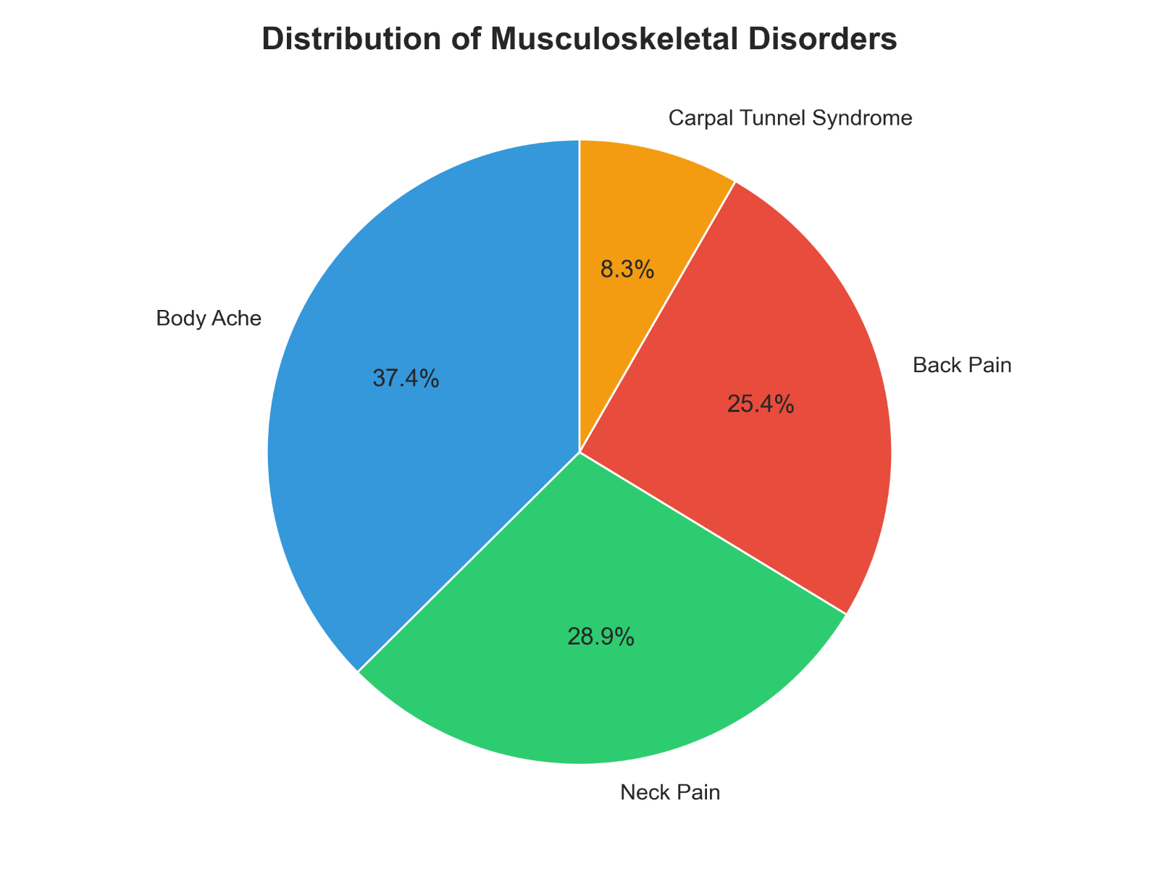

**Social Isolation and its Effects on Mental Well-being**

The nature of IT work, particularly with the increasing trend towards remote work arrangements, can also contribute to social isolation and feelings of loneliness among professionals in the sector. While remote work offers numerous benefits in terms of flexibility, the reduced opportunities for face-to-face interaction with colleagues can negatively impact emotional and social intelligence, which are crucial for effective teamwork and overall well-being. Prolonged periods of working in isolation can lead to feelings of disconnection and loneliness, which have been shown to be detrimental to both mental and physical health, with some studies suggesting that loneliness can be as harmful as smoking cigarettes. Therefore, addressing social isolation among IT professionals, especially in remote settings, is essential for promoting their mental health.

**Workplace Stressors**

Several specific workplace factors contribute to the high levels of stress experienced by IT professionals. The industry is often characterized by a high workload, with employees facing pressure to deliver innovative solutions and meet tight deadlines. The rapid pace of technological change necessitates continuous learning and upskilling, which adds another layer of pressure on IT professionals who must constantly strive to stay relevant in their field. The increasing prevalence of remote work, while offering flexibility, has also brought about new challenges, including the blurring of work-life boundaries. Many IT professionals find it difficult to disconnect from work, leading to longer working hours and a feeling of being perpetually "on call," which can significantly increase stress levels. Furthermore, company culture and management practices play a crucial role in shaping the stress levels of IT professionals. High-pressure work environments, a lack of recognition for their efforts, inadequate management support, and negative team dynamics can all contribute to increased stress and mental health issues. A work culture that normalizes overwork and long hours can further exacerbate these problems, leading to burnout and a decline in overall well-being.

**Metabolic and Hormonal Problems**

The sedentary nature of IT desk jobs and the associated lifestyle factors can also contribute to a range of metabolic and hormonal problems among professionals in this sector. These issues can have significant implications for their long-term health and overall well-being.

**Metabolic Dysfunction**

The predominantly sedentary behaviour inherent in many IT roles has been strongly linked to several metabolic dysfunctions. Prolonged sitting and a lack of physical activity result in lower energy expenditure, making individuals more susceptible to weight gain and obesity. Extended periods of inactivity are also associated with an increased risk of developing metabolic syndrome, a cluster of conditions including increased blood pressure, high blood sugar, excess body fat around the waist, and unhealthy cholesterol levels. Furthermore, a stationary lifestyle has been linked to an elevated risk of developing type 2 diabetes, as inactivity can cause the body to become less sensitive to insulin, leading to elevated blood sugar levels. Studies have shown that individuals who spend a greater amount of time engaged in sedentary behaviors have significantly higher odds of having metabolic syndrome. These metabolic disorders not only impact an individual's physical health but can also contribute to decreased energy levels and an overall decline in well-being. Obesity and related metabolic issues can also act as co-risk factors for other health problems, potentially increasing the susceptibility to conditions like occupational asthma.

Sedentary lifestyles and the associated lack of physical activity also pose significant cardiovascular risks for IT professionals. Prolonged inactivity can contribute to the development of cardiovascular diseases and other heart-related problems, including the damage and clogging of arteries, which can lead to serious events such as heart attacks or strokes. Additionally, the high levels of stress often experienced by IT professionals can further exacerbate these risks, as stress has been linked to an increased likelihood of developing hypertension and other cardiovascular conditions. Dyslipidemia, characterized by unhealthy levels of cholesterol and other lipids in the blood, is also prevalent among IT professionals and can be influenced by both sedentary work patterns and chronic stress. These cardiovascular risks underscore the importance of promoting active lifestyles and stress management techniques within the IT sector.

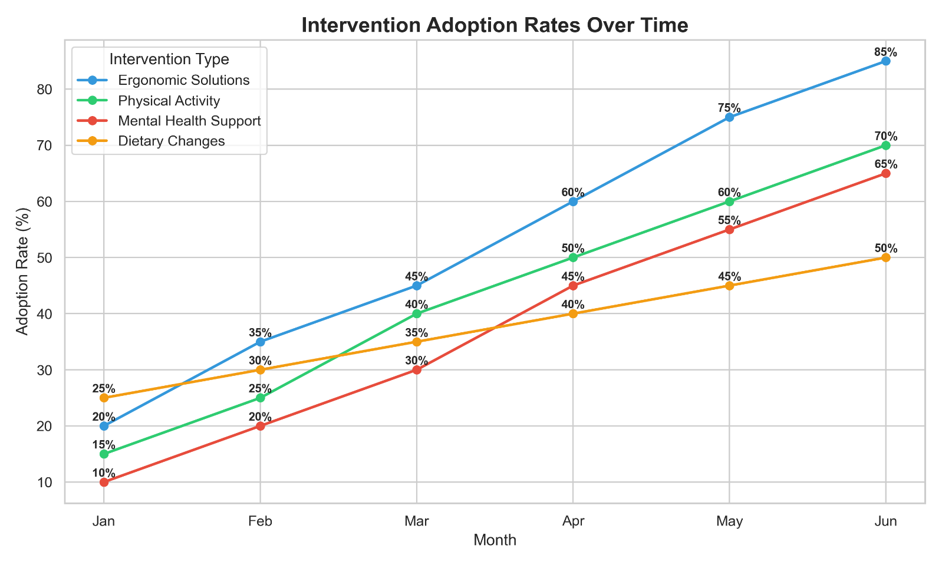

**Hormonal Imbalances**

The work patterns and lifestyle associated with IT professions can also disrupt the delicate balance of hormones in the body. While the typical 9-to-5 schedule might not inherently involve shift work, many IT professionals engage in work outside of these hours, and the pervasive use of digital screens, particularly in the evening, can significantly disrupt the body's natural circadian rhythm and suppress the production of melatonin. Melatonin, a hormone crucial for regulating sleep-wake cycles, is suppressed by the blue light emitted from computer screens, which mimics daylight and can delay the release of melatonin, leading to difficulties in falling asleep and maintaining restful sleep. This disruption of melatonin production can result in sleep problems, chronic fatigue, and may potentially increase the risk of other health issues over time.

Chronic work stress, a common experience for many IT professionals, can also lead to imbalances in hormone levels, most notably the prolonged elevation of cortisol, the body's primary stress hormone. While cortisol plays a vital role in helping the body respond to stress, chronically elevated levels can have detrimental effects on various bodily systems, contributing to weight gain, mood swings, increased blood pressure, and mental health issues. Furthermore, the sedentary lifestyle often associated with IT work has been linked to an increased risk of thyroid dysfunction, particularly hypothyroidism, where the thyroid gland does not produce enough thyroid hormones. Lack of physical activity can lead to lower levels of thyroxine, a key hormone that regulates essential bodily functions such as heart rate and energy levels. The stress prevalent in the IT industry can also disrupt the delicate balance of thyroid hormones, potentially contributing to both underactive and overactive thyroid conditions. Beyond these key hormones, prolonged screen time and chronic stress may also have implications for other hormones involved in appetite regulation and reproductive health, although further research is needed to fully elucidate these potential imbalances in IT professionals.

**Prevalence, Statistics, and Surveys**

The prevalence of health problems among IT professionals is a well-documented concern, with numerous studies and surveys conducted globally and in India providing valuable insights into the scope of these issues.

**Global and India-Specific Data on Prevalence**

Globally, a significant percentage of computer workers experience work-related health problems, with estimates suggesting high rates of musculoskeletal disorders and Computer Vision Syndrome. In India, the situation is equally concerning, with studies indicating that a substantial proportion of IT professionals report physical health problems. Musculoskeletal issues appear to be highly prevalent, with studies reporting rates ranging from 56% to 89%. Vision problems, particularly Computer Vision Syndrome, also affect a large segment of the IT workforce in India, with prevalence rates ranging from 52% to 70% in various studies. Mental health challenges are also widespread, with stress, anxiety, and depression reported by 35% to 54% of Indian IT professionals in different surveys. Furthermore, metabolic disorders such as hypertension (22%), diabetes (10%), dyslipidemia (36%), and obesity (40%) have been found to be prevalent among the Indian IT workforce. The global prevalence of Computer Vision Syndrome among adults is also significant, with reported data varying from 12.1% to 97.3% across different studies. These statistics collectively paint a picture of a workforce facing a considerable burden of health issues across multiple domains.

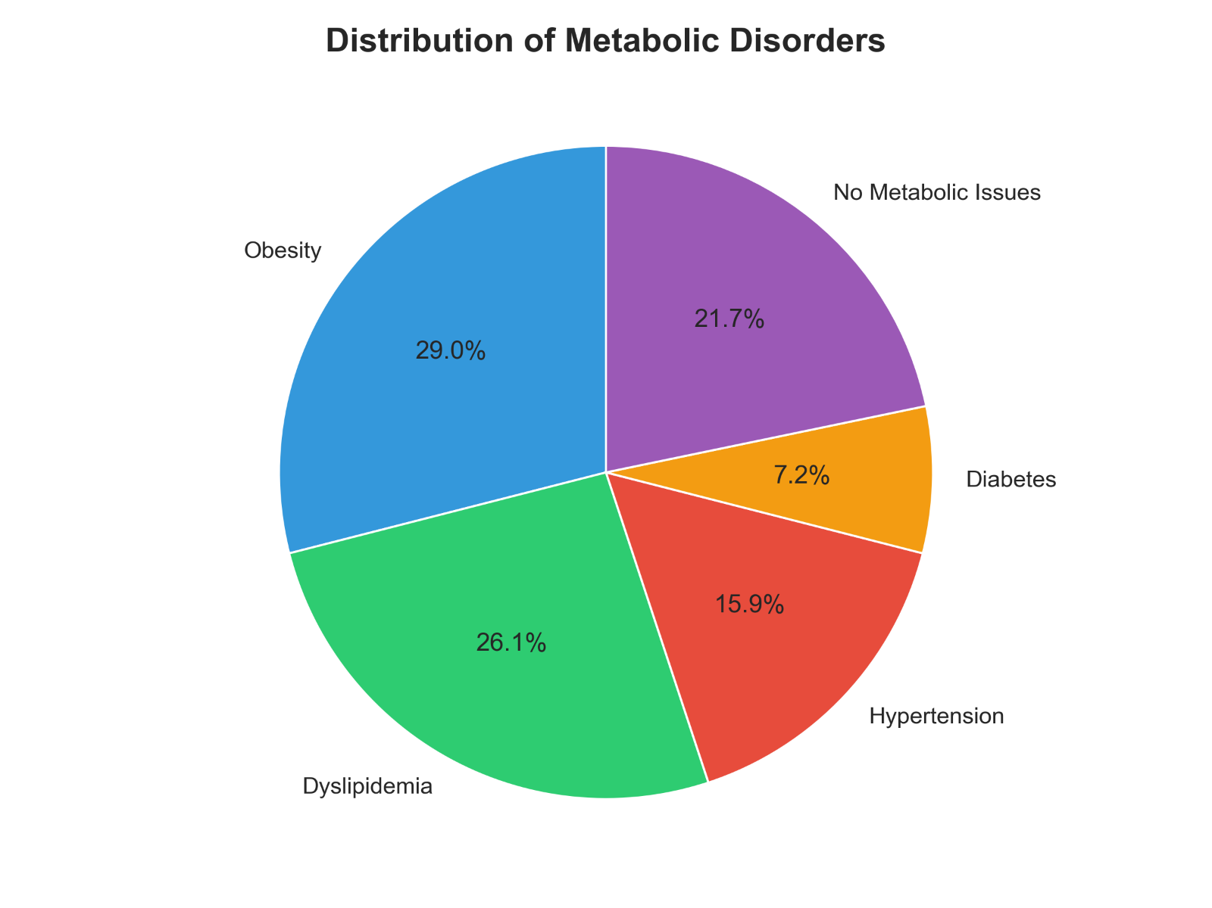

**Analysis of Relevant Research Studies, Surveys, and Reports**

Numerous research studies and surveys have been conducted to investigate the health problems experienced by IT professionals. In India, detailed questionnaires and health checkups have been utilized to gather data on the prevalence and types of health issues affecting IT and BPO employees. These studies often focus on specific areas such as stress levels, musculoskeletal symptoms, and visual problems, providing valuable insights into the most common health complaints within this population. While many surveys have been conducted in urban centers across India, specific comprehensive data focusing solely on IT professionals in Delhi for the entire spectrum of physical, mental, metabolic, and hormonal health problems appears to be limited within the provided research material. Some snippets touch upon general health surveys and digital health information-seeking behavior in the Delhi region, but these do not provide the targeted statistics on IT professionals' health in Delhi as requested. This suggests a potential gap in the existing research that could be addressed through future studies.

**Presentation of Key Statistics, Quantitative Data, and Visualizations**

To better illustrate the trends and patterns of health problems among IT professionals, the following tables provide a summary of prevalence data based on the reviewed studies.

**Table 1: Prevalence of Musculoskeletal Disorders in IT Professionals (Global and India)**

|  |  |  |  |
| --- | --- | --- | --- |
| **MSD Type** | **Global Prevalence (Range)** | **India Prevalence (Range)** | **Snippet IDs** |
| Back Pain | - | Higher than 19.4% | 9 |
| Neck Pain | - | Around 30-45.5% | 9 |
| Shoulder Pain | - | - | - |
| Carpal Tunnel Syndrome | - | Around 13.1% | 17 |
| Body Ache (General) | - | 59% | 9 |
| WRMSDs (Overall) | 20% - 89% | 58% - 71% | 9 |

**Table 2: Prevalence of Computer Vision Syndrome (CVS) in IT Professionals (Global and India)**

|  |  |  |  |
| --- | --- | --- | --- |
| **CVS Prevalence** | **Global Range** | **India Range** | **Snippet IDs** |
| Overall | 50% - 90% | 70% - 80% | 9 |

**Table 3: Prevalence of Mental Health Issues in IT Professionals (India)**

|  |  |  |
| --- | --- | --- |
| **Mental Health Issue** | **Prevalence Range** | **Snippet IDs** |
| Stress | Up to 80% | 48 |
| Anxiety | 35% - 54% | 9 |
| Depression | 35% - 54% | 9 |
| Burnout | Around 40% | 57 |

**Table 4: Prevalence of Metabolic Disorders in IT Professionals (India)**

|  |  |  |
| --- | --- | --- |
| **Metabolic Disorder** | **Prevalence** | **Snippet IDs** |
| Hypertension | 22% | 48 |
| Diabetes | 10% | 48 |
| Dyslipidemia | 36% | 48 |
| Obesity | 40% | 48 |

These tables provide a consolidated view of the significant prevalence of various health problems among IT professionals, both globally and specifically within India. Further analysis and visualization of longitudinal data, if available, could offer additional insights into the trends and patterns of these occupational health challenges.

**Early Detection and Identification Strategies**

Early detection and identification of health problems are crucial for timely intervention, effective management, and preventing the progression of these issues among IT professionals. Various methods and tools can be employed to identify physical, mental, metabolic, and hormonal health problems at an early stage.

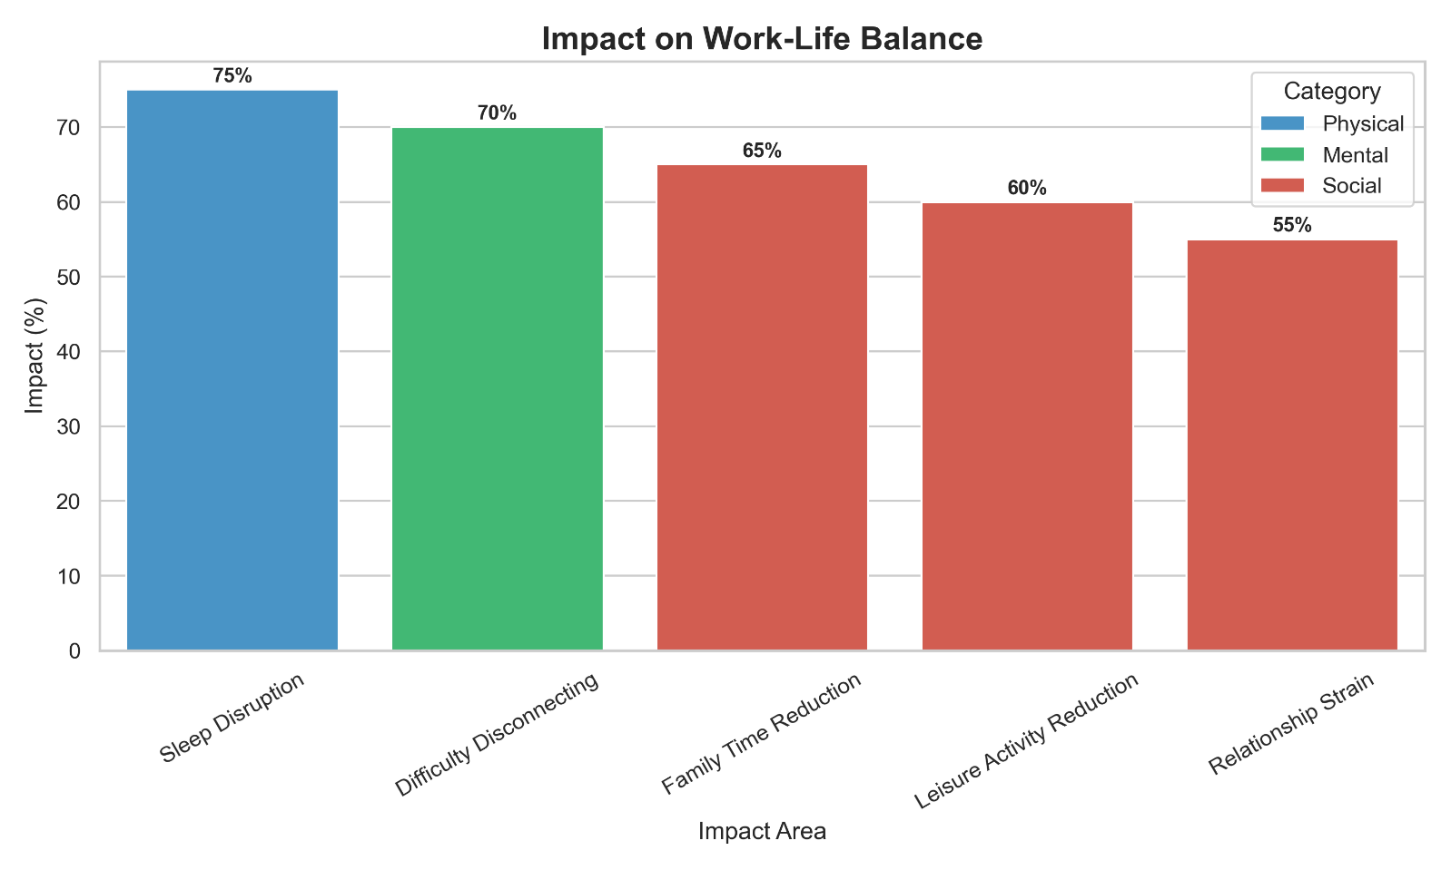

**Methods for Early Detection of Physical Health Problems**

Several strategies can aid in the early detection of physical health problems commonly experienced by IT professionals. Self-assessment questionnaires, such as those designed for Computer Vision Syndrome, can help individuals recognize early symptoms like eye strain, dry eyes, and blurred vision, prompting them to seek professional care. Similarly, raising awareness of the early warning signs of musculoskeletal disorders, such as persistent pain or fatigue in the hands, wrists, arms, shoulders, upper back, or neck, can encourage individuals to take proactive steps before the conditions worsen. Regular ergonomic self-assessments of the workstation setup, focusing on chair height, desk arrangement, monitor position, and the use of supportive accessories, can help identify and address potential risk factors for both MSDs and CVS. By empowering IT professionals with the knowledge of these early indicators and self-assessment techniques, timely intervention and management of physical health problems can be facilitated.

**Screening Tools and Approaches for Mental Health Challenges**

For mental health challenges, the implementation of brief, validated screening tools in the workplace can be highly effective in early identification. Questionnaires such as the Generalized Anxiety Disorder 7-item scale (GAD-7) and the Patient Health Questionnaire-9 (PHQ-9) are widely used to screen for symptoms of anxiety and depression. These tools are easy to administer and can help identify employees who may be at risk for mental health conditions, enabling them to access appropriate support and resources. Regular mental health screenings, conducted periodically within organizations, can contribute to a culture of well-being and encourage early help-seeking behaviors among IT professionals who might otherwise hesitate to discuss their mental health concerns.

**Importance of Regular Health Check-ups for Metabolic and Hormonal Issues**

Early detection of metabolic and hormonal issues relies heavily on regular medical check-ups and occupational health assessments. Routine monitoring of vital signs such as blood pressure, blood sugar levels, and cholesterol levels is essential for the early detection of metabolic syndrome, diabetes, and cardiovascular risks associated with sedentary lifestyles. Occupational health checks, which involve comprehensive evaluations of an employee's physical and mental fitness for their job, can also play a crucial role in identifying potential health problems at an early stage, including musculoskeletal issues and stress-related conditions. For hormonal imbalances, specific blood tests, such as thyroid function tests, can help detect disorders like hypothyroidism or hyperthyroidism. Encouraging IT professionals to undergo regular health check-ups and participate in occupational health assessments can significantly improve the chances of early diagnosis and management of metabolic and hormonal problems.

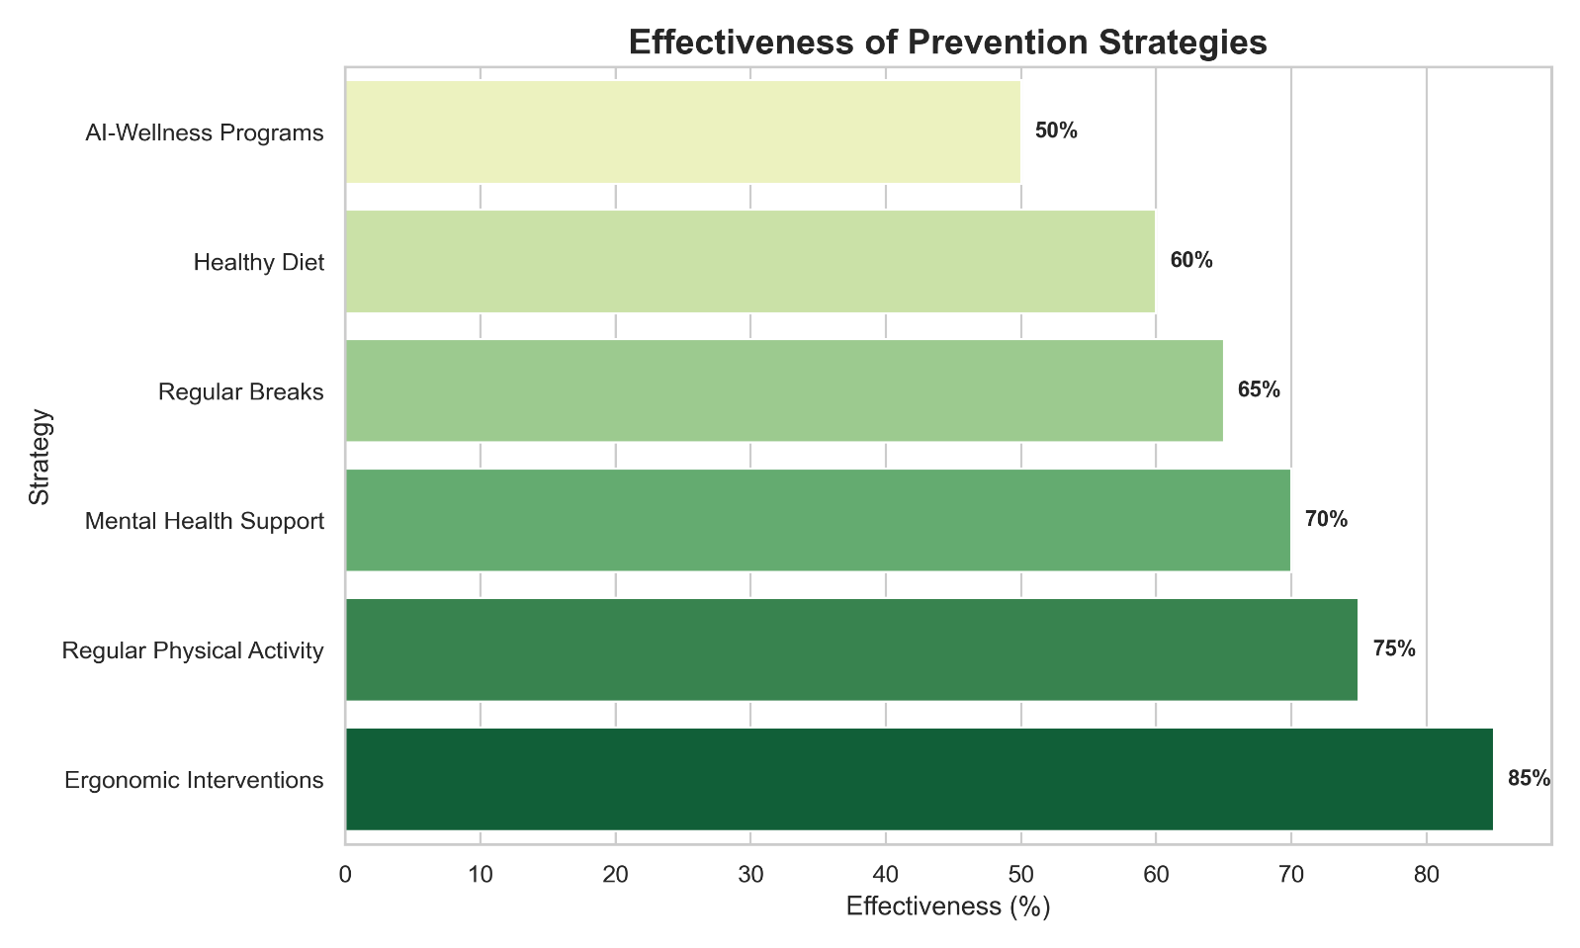

**Role of Biomarkers and Wearable Technology in Early Identification**

The advancement of technology has also opened up new avenues for early detection of health problems through the use of biomarkers and wearable devices. Wearable devices such as smartwatches and fitness trackers can continuously monitor various physiological parameters, including heart rate, sleep patterns, and levels of physical activity. Changes in these metrics can potentially indicate early signs of stress, metabolic shifts, or other health issues. Furthermore, there is ongoing development in wearable technology aimed at non-invasively monitoring hormonal health, which could provide valuable data for early identification of imbalances. The integration of artificial intelligence (AI) with data collected from wearable devices allows for sophisticated analysis and the potential to predict individual health risks, providing personalized recommendations for early intervention and preventative measures. This combination of wearable technology and AI-driven analytics holds significant promise for revolutionizing the early identification and management of health problems among IT professionals.

**Evidence-Based Solutions, Interventions, and Prevention**

Addressing the health challenges faced by IT professionals requires a comprehensive approach that encompasses ergonomic interventions, promotion of physical activity, mental health support programs, lifestyle modifications, innovative workplace design, and the integration of technology-driven wellness initiatives.

**Ergonomic Interventions**

Implementing ergonomic principles in the design and setup of workstations is fundamental to preventing physical health problems such as musculoskeletal disorders and Computer Vision Syndrome. This includes providing employees with adjustable chairs that offer proper lumbar support, ensuring that desks are at an appropriate height to allow for comfortable arm and wrist positioning, and positioning computer monitors at an arm's length away and slightly below eye level to minimize neck strain and eye fatigue. The use of ergonomic accessories such as keyboard and mouse rests can also help maintain neutral wrist positions and reduce the risk of repetitive strain injuries. However, simply providing ergonomic equipment is not enough; it is crucial to train employees on the principles of good posture and the correct way to use and adjust their workstations and accessories to maximize the benefits of these interventions.

**Physical Activity and Movement Strategies**

Combating the negative health effects of prolonged sitting requires a concerted effort to integrate physical activity and movement into the daily routine of IT professionals. Encouraging employees to take short breaks from sitting every 30 minutes to stand up, stretch, and move around can help offset the risks associated with sedentary behavior. Workplaces can also promote movement by encouraging walking meetings instead of seated ones, providing standing desks as an alternative to traditional sitting desks, and designing office layouts that necessitate regular movement for tasks such as accessing printers or supplies. Furthermore, organizations should actively promote and support regular exercise outside of work hours through initiatives such as providing gym memberships, organizing fitness challenges, or offering on-site fitness facilities.

**Mental Health Support Programs**

Given the high prevalence of mental health challenges in the IT sector, implementing comprehensive mental health support programs is essential. This can include offering access to mindfulness practices, meditation sessions, and stress reduction techniques, which have been shown to be effective in managing stress, anxiety, and improving mental clarity. Organizations can also leverage digital mental health interventions, such as cognitive behavioral therapy (CBT) based programs delivered through web or mobile applications, which have demonstrated positive effects on reducing symptoms of stress, anxiety, and depression. Providing employees with access to Employee Assistance Programs (EAPs) can offer confidential counseling and support services for a wide range of mental health and personal issues. A multi-faceted approach that combines these various support mechanisms is likely to be most effective in addressing the mental well-being of IT professionals.

**Lifestyle Modifications for Metabolic and Hormonal Health**

Adopting healthy lifestyle habits is crucial for preventing and managing metabolic and hormonal imbalances. This includes following a balanced diet that is rich in fruits, vegetables, whole grains, and lean proteins, while limiting the intake of processed foods, sugary drinks, and unhealthy fats. Prioritizing good sleep hygiene is also essential for regulating hormone levels, particularly melatonin, and improving overall health. This involves maintaining a consistent sleep schedule, creating a relaxing bedtime routine, and ensuring a sleep-conducive environment. Furthermore, practicing effective stress management techniques, such as regular exercise, mindfulness exercises, spending time on enjoyable hobbies, and maintaining social connections, can help regulate cortisol levels and improve overall well-being. Educating IT professionals about the importance of these lifestyle modifications can empower them to take proactive steps towards improving their metabolic and hormonal health.

**Innovative Workplace Design**

The design of the physical workspace can significantly influence the activity levels and overall well-being of IT professionals. Implementing innovative design principles that encourage movement throughout the day can help combat the risks associated with prolonged sitting. This can include strategically placing common areas such as printers, break rooms, and meeting spaces at a distance from workstations to promote walking. Utilizing interconnecting stairways instead of relying solely on elevators can also encourage more physical activity within the office. Providing standing meeting rooms as an alternative to traditional seated conference rooms can further reduce sedentary time during the workday. The incorporation of sit-stand desks and even treadmill desks offers employees the flexibility to alternate between sitting and standing or walking while working, allowing them to break up prolonged periods of inactivity. By thoughtfully designing workspaces to promote movement, organizations can contribute to a healthier and more active workforce.

**Role of AI-Powered Wellness Programs**

The integration of artificial intelligence (AI) into employee wellness programs offers a novel and increasingly effective approach to supporting the health and well-being of IT professionals. AI-powered platforms can analyze individual health data collected from surveys, wearable devices, and other sources to provide personalized wellness program recommendations tailored to each employee's specific needs and goals. This can include customized fitness plans, nutritional advice, and stress management techniques. AI-driven chatbots and virtual coaches can offer 24/7 support and guidance on a wide range of wellness topics, providing employees with convenient access to information and assistance whenever they need it. These AI-powered systems can also play a crucial role in early detection by analyzing data to identify potential health risks and even screen for early signs of mental health concerns, connecting employees with appropriate resources and support. By leveraging the power of AI, organizations can deliver more personalized, proactive, and accessible wellness interventions to their IT professionals, ultimately fostering a healthier and more engaged workforce.

**Impact on Family Life and Work-Life Balance**

The health problems experienced by IT professionals due to their work can have significant spillover effects on their family life and overall work-life balance. The high levels of stress, physical discomfort, and mental health challenges can extend beyond the workplace and impact their relationships with family members.

**Exploring the Spillover Effects of Work Stress and Health Problems on Family Relationships**

Workplace stress, a common experience for many IT professionals, can easily spill over into their personal lives, leading to increased irritability, frequent mood swings, and a general strain on family relationships. The long working hours often required in the IT sector can significantly reduce the time available for family activities and can create conflict as professionals struggle to balance their work demands with their responsibilities at home. Furthermore, the physical and mental health problems that arise from work, such as chronic pain, fatigue, anxiety, or depression, can cause further concern and strain within the family unit, affecting the individual's ability to participate fully in family life and potentially impacting the emotional well-being of other family members. The inability to disconnect from work, often exacerbated by the constant connectivity afforded by technology, can further intrude on family time and create a sense of imbalance and conflict.

**Challenges in Balancing Work and Family Responsibilities in the IT Sector**

Achieving a healthy balance between work and family responsibilities is a significant struggle for many IT professionals. The prevalent "always on" culture within the industry, coupled with the blurring of work-life boundaries due to the pervasive use of technology, makes it particularly challenging for individuals to disconnect from their work and dedicate sufficient time and energy to their families and personal lives. The often long and unpredictable working hours, driven by project deadlines and the demands of a globalized industry, further exacerbate these challenges, leaving professionals feeling as though they are constantly juggling competing priorities. This constant pressure to meet work demands can often come at the expense of time spent with family, leading to feelings of guilt, dissatisfaction, and an overall imbalance in life.

**Strategies for Improving Work-Life Integration and Reducing Conflict**

Improving work-life integration and reducing the conflict between work and family responsibilities requires a multifaceted approach involving both individual strategies and supportive organizational policies. Establishing clear boundaries between work and family time is essential, which can include designating specific "no work" times or areas within the home that are free from work-related activities. Organizations can play a crucial role by implementing flexible work arrangements and policies that support employees in achieving a better work-life balance, such as telecommuting options, flexible work schedules, and adequate paid time off. Promoting a company culture that genuinely values work-life balance and encourages employees to disconnect from work outside of designated hours is also critical. Encouraging open communication between employees and managers about workload, expectations, and the need for flexibility can help mitigate work-family conflict and ensure that individuals feel supported in managing their responsibilities both at work and at home. Ultimately, achieving a healthier work-life integration requires a collective effort from individuals, organizations, and even broader societal norms to recognize the importance of both professional success and a fulfilling personal life.

**Conclusion**

The analysis presented in this report underscores the significant and interconnected health challenges faced by IT professionals engaged in sedentary desk jobs with prolonged computer use. From musculoskeletal disorders and vision problems to mental health challenges, metabolic dysfunction, and hormonal imbalances, the nature of work in the IT sector poses a considerable risk to the well-being of its workforce. The high prevalence of these issues, both globally and specifically in India, demands a comprehensive and proactive approach to occupational health within this industry.

To address these challenges, a holistic strategy is required that integrates ergonomic interventions to optimize the physical workspace, promotes regular physical activity and movement throughout the workday, provides robust mental health support programs, encourages healthy lifestyle modifications targeting diet, sleep, and stress management, and fosters innovative workplace design that prioritizes employee well-being. Furthermore, the integration of AI-powered wellness programs offers a promising avenue for delivering personalized and proactive health recommendations. Addressing the impact of work-related health issues on family life and promoting a better work-life balance through supportive policies and a positive company culture are also critical components of a comprehensive approach.

Looking ahead, future research should focus on longitudinal studies to better understand the long-term health trajectories of IT professionals, the effectiveness of various interventions in this specific population, and the unique challenges faced by professionals in regions like Delhi, India. Continued innovation in early detection methods, preventative strategies, and supportive workplace environments will be essential for mitigating the silent epidemic of occupational health challenges within the information technology sector and ensuring a healthy, productive, and engaged workforce for the future.

**Works cited**

1. The Computer Vision Syndrome and Associated Factors Among Medical and Engineering Students in Chennai
2. <https://www.researchgate.net/publication/261841356_Computer_Vision_Syndrome_and_Associated_Factors_Among_Medical_and_Engineering_Students_in_Chennai>
3. Computer Vision Syndrome and Associated Factors Among Medical and Engineering Students in Chennai <https://www.researchgate.net/publication/261841356_Computer_Vision_Syndrome_and_Associated_Factors_Among_Medical_and_Engineering_Students_in_Chennai>
4. Burnout in software engineering: A systematic mapping study

<https://www.sciencedirect.com/science/article/pii/S0950584922002257>

1. Healthy workplace with ergonomics among software engineers: a review

<https://www.researchgate.net/publication/336111646_Healthy_workplace_with_ergonomics_among_software_engineers_a_review>

1. All in the (engineering) Family? - the Family Occupational Background of Men and Women Engineering Students

<https://www.researchgate.net/publication/241324483_All_in_the_engineering_Family__the_Family_Occupational_Background_of_Men_and_Women_Engineering_Students>

1. Mental Wellbeing at Work: Perspectives of Software Engineers

<https://dl.acm.org/doi/10.1145/3544548.3581528>

1. Diets, Lifestyles and Metabolic Risk Factors among Corporate Information Technology (IT) Employees in South India

<https://www.researchgate.net/publication/372791725_Diets_Lifestyles_and_Metabolic_Risk_Factors_among_Corporate_Information_Technology_IT_Employees_in_South_India>

1. Practical Solutions for Harmonics Problems Produced in the Distribution Networks

<https://www.researchgate.net/publication/26488790_Practical_Solutions_for_Harmonics_Problems_Produced_in_the_Distribution_Networks>

1. Prevalence and Pattern of Musculoskeletal Problem among Software Engineers in a Private Firm, Chennai- A Cross Sectional Study

<https://www.researchgate.net/publication/350626602_Prevalence_and_Pattern_of_Musculoskeletal_Problem_among_Software_Engineers_in_a_Private_Firm_Chennai-A_Cross_Sectional_Study>

1. Sedentary behavior and obesity

<https://www.researchgate.net/publication/51416557_Sedentary_behavior_and_obesity>

1. Need for Sleep: the Impact of a Night of Sleep Deprivation on Novice Developers’ Performance

<https://oa.upm.es/65069/1/INVE_MEM_2019_324223.pdf>

1. IMPACT OF STRESS ON IT PROFESSIONALS: IDENTIFIED STRESS COPING STRATEGIES WITH REFERENCE TO IT COMPANIES

<https://www.researchgate.net/publication/372680176_IMPACT_OF_STRESS_ON_IT_PROFESSIONALS_IDENTIFIED_STRESS_COPING_STRATEGIES_WITH_REFERENCE_TO_IT_COMPANIES>

1. Trends in Cardiovascular Engineering and Its Advances

<https://www.researchgate.net/publication/369317293_Trends_in_Cardiovascular_Engineering_and_Its_Advances>

1. HEALTH PROBLEMS AMONG INFORMATION TECHNOLOGY WORKER AND ITS IMPACT ON FAMILY LIFE

<https://www.researchgate.net/publication/359312979_HEALTH_PROBLEMS_AMONG_INFORMATION_TECHNOLOGY_WORKER_AND_ITS_IMPACT_ON_FAMILY_LIFE>

1. Work-Related Musculoskeletal Health Disorders among the Information Technology Professionals in India: A Prevalence Study

<https://www.researchgate.net/publication/256089219_Work-Related_Musculoskeletal_Health_Disorders_among_the_Information_Technology_Professionals_in_India_A_Prevalence_Study>

1. Assessment of Forward Head Posture in Information Technology Employees with Neck Pain: A Cross-Sectional Study

<https://www.researchgate.net/publication/378473895_Assessment_of_Forward_Head_Posture_in_Information_Technology_Employees_with_Neck_Pain_A_Cross-Sectional_Study>

1. Associations of screen work with neck and upper extremity symptoms: A systematic review with meta-analysis

<https://www.researchgate.net/publication/331912808_Associations_of_screen_work_with_neck_and_upper_extremity_symptoms_A_systematic_review_with_meta-analysis>

1. Health problems and stress in Information Technology and Business Process Outsourcing employees

<https://www.researchgate.net/publication/276129034_Health_problems_and_stress_in_Information_Technology_and_Business_Process_Outsourcing_employees>

1. Study of Prevalence of Health Problems Among Computer Professionals in Selected Information Technology (IT) Company In Nagpur District of Central India.

<https://www.researchgate.net/publication/274887980_Study_of_Prevalence_of_Health_Problems_Among_Computer_Professionals_in_Selected_Information_Technology_IT_Company_In_Nagpur_District_of_Central_India>

1. Computer vision syndrome: A review

<https://www.researchgate.net/publication/273813532_Computer_vision_syndrome_A_review>

1. To study the impact of screen time on IT job professionals in India

<https://www.researchgate.net/publication/374220293_To_study_the_impact_of_screen_time_on_IT_job_professionals_in_India>

1. A Study to Assess Mental Health among IT Professionals in Selected Company, Kancheepuram District, Tamil Nadu

<https://www.researchgate.net/publication/371731491_A_Study_to_Assess_Mental_Health_among_IT_Professionals_in_Selected_Company_Kancheepuram_District_Tamil_Nadu>

1. A REVIEW ON THE FACTORS LEADING TO EMPLOYEE BURNOUT IN IT SECTOR

<https://www.researchgate.net/publication/316706983_A_REVIEW_ON_THE_FACTORS_LEADING_TO_EMPLOYEE_BURNOUT_IN_IT_SECTOR>

1. Cognitive impairments, information technology systems and the workplace

<https://www.researchgate.net/publication/234800706_Cognitive_impairments_information_technology_systems_and_the_workplace>

1. Social issues in software engineering

<https://www.researchgate.net/publication/3640400_Social_issues_in_software_engineering>

1. A STUDY ON JOB STRESS AMONG IT EMPLOYEES

<https://www.researchgate.net/publication/353700748_A_STUDY_ON_JOB_STRESS_AMONG_IT_EMPLOYEES>